

NONDISCRIMINATION IN SERVICES POLICY STATEMENT

TO: Patients/Clients/Residents/Parents
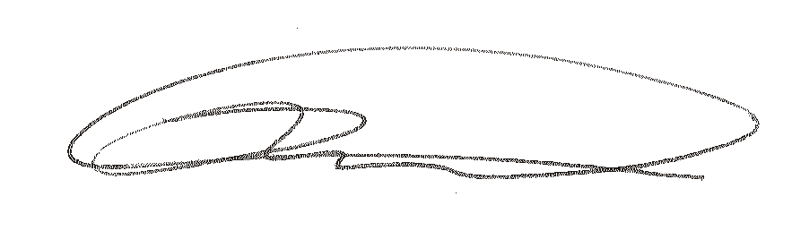
FROM: Dr. Larry Nulton

Admissions, provision of services, and referrals of consumers shall be made without regard to race, color, religious creed, disability, ancestry, national origin, (including limited English proficiency), age, or sex.

Program services shall be made accessible to eligible persons with disabilities through the most practical and economically feasible methods available. These methods include, but are not limited to, equipment redesign, provision of aides, and the use of alternative service delivery locations. Structural modifications shall be considered only as a last resort among available methods.

Any individual/client/patient/student (and/or their guardian) who believes they have been discriminated against may file a complaint of discrimination with:

Peerstar LLC
2900 Plank Road, Suite 8
Altoona, PA 16601
Attn: Lori Miller
1-888-733-7781

Commonwealth of Pennsylvania
Department of Human Services
BEO/Office of Civil Rights Compliance
Room 225 Health & Welfare Building
PO Box 2675
Harrisburg, PA 17120
Inquiries (717)787-1127
Email: RA-PWDHSCivilRights@pa.gov

Pennsylvania Human Relations Commission
333 Market Street, 8th Floor
Harrisburg, PA 17101-2210
https://www.phrc.pa.gov/File-a-complaint
Inquiries: (717)787-4410
TTY users only: (717)787-7279

Office for Civil Rights
U.S. Dpt. Of Health & Human Services
Centralized Case Management Operations
200 Independence Avenue, S.W.
Room 509F HHH Bldg
Washington, D.C. 20201
Customer Response Center: (800)368-1019
TDD: (800)537-7697
https://www.hhs.gov/ocr/complaints
Email: ocrcomplaint.hhs.gov

